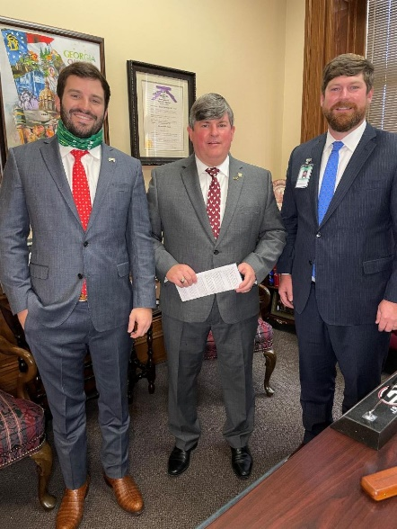
WEEK FOUR LEGISLATIVE REPORT
Week four of the Georgia Legislative Session wrapped up on Thursday afternoon with legislators heading back to their districts after a busy week in Atlanta. The Senate Appropriations process was in full swing as Senators were reviewing the recently passed House budget and working to include their priorities in the state's amended FY 21 spending. The Senate appropriations subcommittee for Agriculture and Natural Resources, chaired by Senator Larry Walker, worked long hours to find the much needed funding that is vital to our industry. We expect to see the Senate version on the floor for debate early next week.

With very few other bills being debated openly in committees this week, much of the groundwork for legislation was happening behind the scenes. GAC staff continued working with legislators and state leaders on several key priority issues involving COVID-19 liability, Georgia's tax code, dairy industry, veterinarians, private property rights, labor force, and others. We've also met with staff in the Governor's office and Department of Public Health to express our concerns regarding the rollout of the coronavirus vaccine to veterinarians and all essential agribusiness workers in the 1B group.

The adjournment resolution agreed to by both chambers several weeks ago ends on February 8th, so next week’s session days are still up in the air for everyone except the select few that make those decisions.

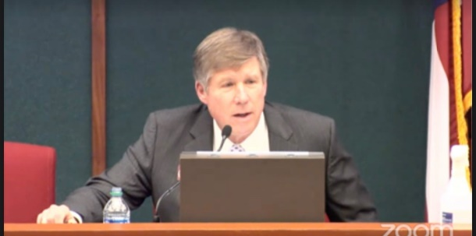
CHAIRMAN DICKEY HOLDS FIRST HOUSE AG COMMITTEE MEETING
Chairman Robert Dickey held the first Agriculture and Consumer Affairs committee meeting under his new leadership on Wednesday morning. Representative Dickey led with welcoming sentiments and introductions of the new members of the committee, followed by the adoption of committee rules. Commissioner Gary Black gave a brief update on the work of his department during the pandemic and what legislation his department expects to see throughout session.

The committee also heard HB 152 pertaining to the Fair Business Practices Act of 1975 proposed by Rep. Marcus Wiedower. The legislation would update Georgia code to require solicitations from non official sources regarding state licenses to include bold lettering stating that the mail is not an official letter of the government and is actually a solicitation. The bill was passed through committee unanimously.

DNR PRESENTS IN HOUSE HOUSE NATURAL RESOURCES COMMITTEE
Chairwoman Lynn Smith held the first House Natural Resources and Environment Committee of the session this week. The meeting began with brief introductions from the attending legislators and swift adoption of the rules. The DNR Commissioner Mark Williams gave a presentation highlighting the Georgia Outdoor Stewardship Act. The DNR administers this state federal Grant program and provides annual designated funding to projects that support conservation, outdoor recreation, and land acquisition. The second grant cycle begins anew this year and is expected to receive $26 million for counties across the state.
Each department within the DNR gave brief updates on their programs and issues around the state.
- Environmental Protection Division headed by Director Richard Dunn disused water supply issues. He updated the committee on the status of the “Water Wars” in Georgia as the Supreme Court has schedule oral arguments to take place on February 22, 2021 at 10 a.m.
- The Coastal Resources Division Director, Doug Haymans, stated that shrimp and recreational fishing have not been heavily affected by the pandemic, while the shellfish industry has lagged this past year.
- Law Enforcement Division Director, Col. Thomas Barnard, reported that most of their department’s activity has revolved around upholding state and federal enforcement laws in response to both the pandemic and civil unrest experienced across the state.
- Parks, Recreation and Historic Sites Division director, Jeff Cown, announced that Georgia state parks remained open during the pandemics, but did limit access to ensure social distancing and shifted administration to online platforms. Over 1.3 million more visitors this year alone visited state parks a 23% increase over last years numbers.
- Director Will Ted of the Wildlife Resources Division has seen a tremendous year in hunting and outdoor recreation as license registration have significantly increased.

There were no new bills brought forward this week.
SENATE BILLS
SB 29: Sen. Anavitarte - Bill would require citizens who want to vote in a Georgia election by absentee ballot to include a copy of their driver's license, voter ID card, passport, or other official form of US identification when they apply for the absentee ballot and at the time of submittal. Assigned to House Ethics Committee

SB 30: Sen. Beach - SB 30 would provide for pari-mutuel horse racing in Georgia and would establish Georgia Horse Racing Commission. Assigned to House Regulated Industries and Utilities Committee

HOUSE BILLS
HB 98: Rep. Eddie Lumsden - bill would authorize counties and cities to conduct “public hearings” by teleconference during emergency conditions (e.g. pandemics). The policy would acknowledge that participation by teleconference would be equal to full in person participation as if those conducting the public hearing are physically present and members of the public must be afforded the means to participate fully in the same manner as if they were physically present. The legislation comes from several instances around the state where local municipalities struggled to conduct the business of their boards as quorums where not met because of health concerns of in person meetings. Assigned to Government Affairs Committee.

HB 104: Rep. Stevens - relating to specific, business, and occupation taxes, so as to levy and impose a tax on persons who enter certain rental agreements with certain equipment rental companies within a certain period of time; to require such equipment rental companies to collect such taxes and remit them to county tax commissioners for credit against such company's ad valorem tax liability for certain equipment; to provide that county tax commissioners shall retain excess fees; to provide for the reporting of certain statistical data related to such tax; to provide for rules and regulations; to provide for definitions; to provide for related matters; to repeal conflicting laws; and for other purposes. Assigned to Ways and Means

HB 112: Rep. Trey Kelley - COVID-19 liability protections for Georgia businesses and hospitals would be extended until July 14, 2022, under a bill introduced in the General Assembly. Since August, the liability protections have shielded businesses and health-care facilities in Georgia from lawsuits brought by people who contract COVID-19 in all but the worst negligence or recklessness cases. The bill only calls for a one-year extension. Assigned to Judiciary Committee

HB 139: Rep Mainor - This bill would prohibit trains from restricting traffic crossing for longer than 15 minutes except in emergency situations. Assigned to House Transportation Committee

HB 150: Reps. Williamson, Hatchett, Kelley, Frazier, Parsons, Smith - HB 150 would prohibit local government entities in Georgia from banning the connection of any utility service based on the type or source of fuel. Assigned to House Energy, Utilities, and Telecommunications Committee

