2019 Legislative Session
Legislative Days 5-7 February 1, 2019

A Start-and-Stop Beginning
The 2019 session is off to an erratic start. After meeting four days in mid-January, the General Assembly used the week of the MLK Holiday to review Governor Brian Kemp’s budget recommendations and hear directly from agency heads regarding funding requests.

The House and Senate were scheduled to meet Monday through Wednesday this week but the threat of winter weather suspended state business on Tuesday. As a result, the Senate gaveled in for the day but completed no other business; the House met to assign bills to committees but took little other action. They had already planned to be out through next Tuesday to avoid the chaos of Sunday’s Super Bowl.

Activity is expected to ramp up considerably next week. They’ll reconvene on Tuesday and meet for the remainder of the week, finally giving committees time to dive into legislation. Leadership is also expected to announce another legislative schedule covering the duration of the session.

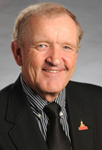
Committee Membership Update
House Committee assignments were still pending when the last legislative report was distributed. The Agriculture and Consumer Affairs Committee remains under the steady leadership of Tom McCall (R-Elberton). McCall is a grain and livestock farmer; he holds a Bachelor’s degree in Agronomy with a focus in Animal Science from the University of Georgia. He has served in the legislature since 1994.

New committee members include:
Tom McCall
- John Corbett, R-Lake Park (timber farmer, currently in his third term),
- Don Hogan, R-St. Simon’s Island (retired, currently in his second term),
- Danny Mathis, R-Cochran (funeral home operator, currently in his first term),
- Steven Meeks, R-Screven (farmer, currently in his first term),
- Ken Pullin, R-Zebulon (financial technology, currently in his first term), and
- Matthew Wilson, D-Brookhaven (attorney, currently in his first term).
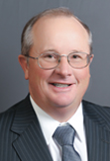 | 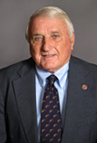 | 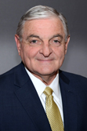 | 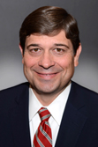 | 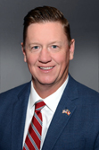
John Corbett | Don Hogan | Danny Mathis | Steven Meeks | Ken Pullin | Matthew Wilson

Veterinary Medicine Day at the Capitol
Wednesday, January 30 was Veterinary Medicine Day. About a dozen legislators joined the group for breakfast before hearing from Agriculture Commissioner Gary Black and State Veterinarian Dr. Robert Cobb. Veterinarians were also recognized in the Senate by Agriculture and Consumer Affairs Committee Chairman John Wilkinson (R-Toccoa) and presented with a copy of SR 22, declaring it to be Veterinary Medicine Day at the state capitol. Thanks to everyone who braved the chilly weather to join colleagues for a fun and informative day on the hill.
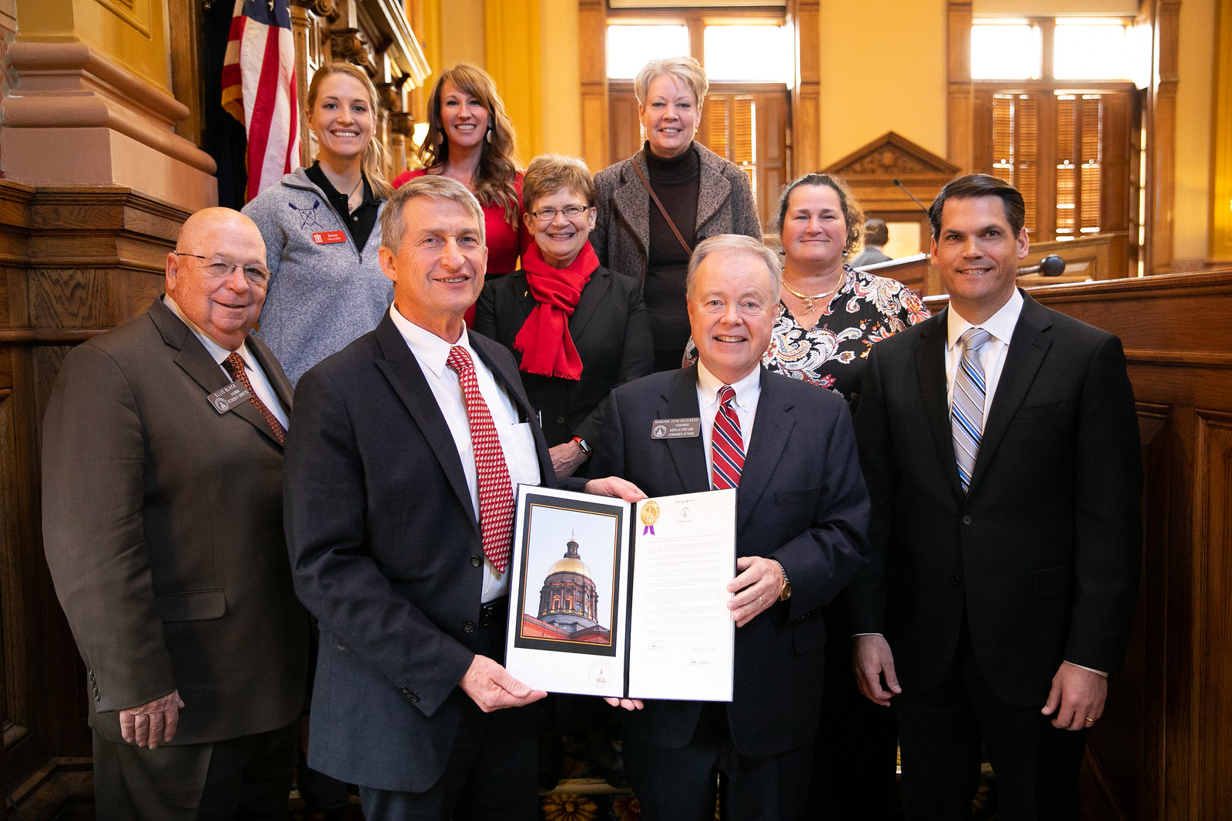
Members of the Association with Senators Ellis Black and John Wilkinson and Lt. Governor Geoff Duncan

Priority Issues
Practice Act. The profession is in the middle of another proactive session and intends to introduce legislation to make a variety of clean-up changes to the Practice Act. The Association is currently working with members of the Senate Agriculture and Consumer Affairs Committee to file legislation that will:
- Add a veterinary technician to the state board. This was inadvertently left out of the comprehensive practice act update from last year.
- Create a professional health program to aid in recovery efforts of impaired veterinarians.
- Rebrand “veterinary technicians” as “veterinary nurses” to reflect their current role and responsibilities in patient care.

Compounding. The Association is actively working with the Georgia Board of Pharmacy and the Georgia Pharmacy Association to allow veterinarians to dispense non-controlled compounded drugs from a hospital supply in emergency care situations for a limited time. The hope is that the Association can avoid legislation and make this permissible through Board rule changes.

Professional Issues
HB 112: Dextromethorphan Rep. John LaHood, R-Valdosta
Prefiled in the House on 1/30
HB 112 prohibits the sale to and by minors of all drugs containing dextromethorphan, commonly found in cough suppressants. The prohibition would extend to veterinary applications.

Industrial Hemp and CBD Oil. As discussed during Veterinary Medicine Day at the State Capitol, in December Congress adopted the 2018 Farm Bill and essentially legalized industrial hemp. For decades, federal law has not differentiated hemp from other cannabis plants, all of which were made illegal in 1970. According to the Farm Bill, “hemp” cannot contain more than 0.3% of THC, the component commonly associated with getting high.

While only the federal government had the authority to declassify industrial hemp, Georgia lawmakers have also been working on the issue. Sen. Matt Brass, R-Newnan, co-chaired a study committee on Low THC Medical Oil Access. After careful study and input from the public, the group recommends lawmakers create a regulated system of in-state production of medical oil. Legislation is expected to be filed in the House in the coming weeks.

Animal Welfare & Regulation Issues
SB 32: Animals in Hot Cars Sen. Kay Kirkpatrick, R-Marietta
Assigned to the Senate Special Judiciary Committee on 1/30
This legislation is the direct product of the Senate Study Committee on Service Animals. It limits the liability for property damage caused by the rescue or attempted rescue of animals locked in motor vehicles, so long as the person first contacts emergency services. Similar legislation – SB 31 – has also been filed; its liability limitation only applies to law enforcement officers attempting to rescue pets, not animals generally.

Taxation Issues
HB 35: Poultry Disease Monitoring Services Rep. Sam Watson, R-Moultrie
Assigned to the House Ways and Means Committee on 1/28
This bill creates a state sales tax exemption for sales to or by a nonprofit organization whose primary purpose is to provide poultry diagnostic and disease monitoring services. The bill comes at the request of the poultry lab in Tifton. Watson sponsored an identical bill last year.

HB 13: Horse Show Exemption Rep. Rick Williams, R-Milledgeville
Prefiled in the House on 1/8
Similar to HB 854 pursued by the author last year, HB 13 creates an exemption from state sales taxes for participation fees or admission prices for certain nonprofit horse shows, rodeos, or livestock events or exhibitions. While last year’s effort had enough support to come out of the House Ways and Means Committee, it did not advance.

Licensing Issues
In response to systemic underfunding issues, the GVMA is working with like-minded associations to lobby the General Assembly towards a solution that would give each professional licensing board the ability to set its own fees commensurate with the level of service, staffing and enforcement desired. It could also include a mechanism to ensure licensure fees are appropriated back to the boards.

It is essential to note that dissatisfaction with the professional licensing division is not a criticism of former Secretary Brian Kemp, current Secretary Brad Raffensperger, office employees or members of individual boards. Issues are longstanding, span many different administrations, and are ultimately the result of underfunding: Georgia’s 41 professional boards generate approximately $18 million in fees, yet they receive only about $8 million back from the state for operations. This is likely to be a multi-year effort.

The next legislative update will be available February 8

